Designing an Architecture
Model Diagram:
Figure 1: FSC / UML hybrid. The cyan box represents the fixed state machine, while the green boxes represent various key subcomponents and hardware that the system must interact with. The
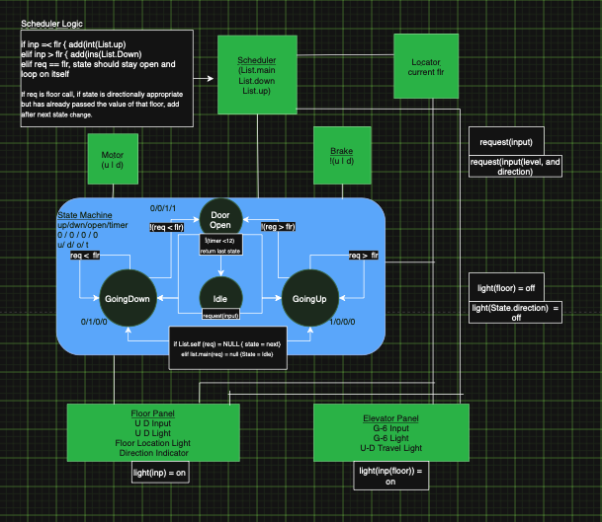

System Overview:
The core of the system is programmed as a Fixed State Machine (FSM). Each state dictates the set of signals that are communicated to the other components and hardware interfaces. Each individual state also includes the logic by which one state will either remain stable or convert and which subprocesses occur in these intermittent cycles.
The other components function to both transmit and/or receive information to ensure the state machine is properly updated, and the various components’ tasks are initiated at the proper times. The scheduler component helps to organize incoming information into the proper logic. Intuitively, the more general hardware interfaces such as the break, motor, notifying and button terminal interfaces communicate directly with those components (doors, lights, breaks, etc.) and send user input signals (buttons) to the scheduler. The locator functions to track and inform the rest of the system where the elevator is in real time.
Together the locator and in slightly lesser sense the scheduler work as the Observer . An observer design pattern allows the system to track the active changes and notify the various components and state machine nodes about each change in real time which in turn allows the system subcomponents and processes to coordinate effectively.

System Process Specs:

-Cabin Terminals and Floor Terminals feature buttons that correspond to standard inputs: Up, Down, Ground Floor, Floor #, etc. (Emergency/Aux systems not addressed in this assignment).
-These buttons are illuminated to indicate they are scheduled. The notification panels on these terminals display the current direction of travel as well as the current location of the Elevator.
-Terminals communicate inputs to the Scheduler and to themselves for illumination. The locator notifies these terminals so that indicators are accurate and button de-register when the elevator arrives at their location in the matched state (Going up, vs Going Down).
-After state 0/0/1/1 (Door Open) sequence complete the machine transitions into Idle. It then checks for it last state and checks its schedule. If remaining floors exist in its previous direction state it resumes it direction of travel by returning to that recent state. If the prior state list is NULL, it transitions to checking the list of the opposite state. If that is NULL the elevator remains in Idle until a request is made. This ensures fairness and efficiency.
-The scheduler compiles state-specific lists ensuring that are informed by the locator to make sure requests are scheduled to the correct state base on current direction and location.

